**Science Boxes #1** Due Date: _________

1. Which of the following processes is

responsible for changing liquid water

into water vapor?

A. photosynthesis

B. condensation

C. evaporation

D. precipitation

1. Which of the following questions is testable in a scientific investigation?

A. Are dogs better pets than cats?

B. Are dogs happy when they are walked?

C. Are cats more active at night than during the day?

D. Are cats easier to take care of than dogs?

1. A student will measure and record the growth

of two flowering plants every other day for 10 days.

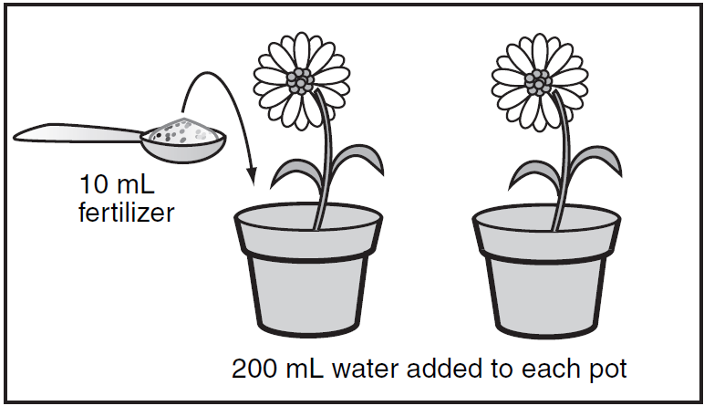

According to the diagram, which question is being tested?

1. Do flowering plants grow better when watered with salt water?
2. How much fertilizer do flowering plants need?
3. Does fertilizer added to the soil lead to taller flowering plants?
4. How tall do flowering plants grow?

Name: __________________________

1. Above a continent, a warm air mass slowly passes over a cold air mass. As the warm air begins to cool, clouds form. What will most likely happen next?
2. Rain will fall.
3. Hurricanes will form.
4. Lightning will strike.
5. Hail will form.
6. How do plants most commonly break large rocks into smaller pieces?
7. Plant leaves insulate surrounding rocks from extreme temperatures.
8. Plant roots grow into cracks in rocks.
9. Seeds from plants fall onto rocks and release acidic compounds.
10. Stems of plants surround and squeeze rocks.



Which process is most responsible for the formation of the Grand Canyon?

1. scouring by continental glaciers
2. erosion by wind and water
3. eruptions by explosive volcanoes
4. cracking of Earth’s crust by earthquakes