Science Boxes #2 Due Date: _________

- Natural processes can break large rocks into smaller pieces. Below, identify and describe two processes that can break rocks apart. (2 points)

- The weather systems shown below will move by September 16.
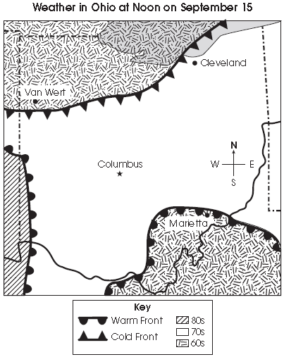
Based on the weather map, which city will be next to experience cooler temperatures?
- A. Van Wert
- B. Cleveland
- C. Columbus
- D. Marietta
Name: __________________________

- Scientists found fish fossils in the desert.
What do the fossils tell about this environment when the fish were alive?
A. There was a forest with large trees.
B. There were lakes with water plants.
C. There were mountains with glaciers.
D. There was a desert with large rocks.

- A student stands outside on a cold winter day.
His hands become cold and he rubs them together to make them warmer.
Which statement explains why rubbing his hands together makes them warmer?
A. This action produces thermal energy through friction.
B. This action conducts thermal energy away from the body.
C. This action captures thermal energy from the environment.
D. This action reduces the amount of thermal energy transferred to the air.
- A student is collecting data about the wind.
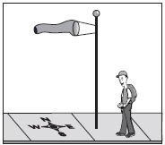

The picture shows a windsock attached to a flagpole on a windy day. According to the information in the picture, the wind is coming from which direction?
A. from the east
B. from the west
C. from the north
D. from the south

