Science Boxes 7-2 Due Date: _________

1. A student studying rock densities needs to measure the volume of a small rock sample to the nearest milliliter (mL). The student knows that the rock sample has a volume of at least 5 mL. Which tool should the student use to get the most accurate measure of the volume of water displaced by the rock?
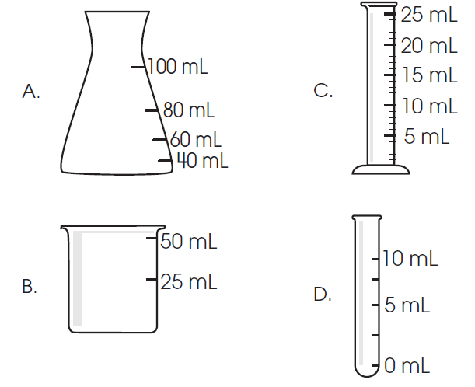
Use the information in the diagram to answer questions 2–4.
Density Experiment
The two graduated cylinders pictured can hold the same amount of water and use the same scale. A student measures the masses of two metal balls. One ball is made of aluminum and the other ball is made of lead. The student adds 50 mL of water to each graduated cylinder and then drops one metal ball into each graduated cylinder.
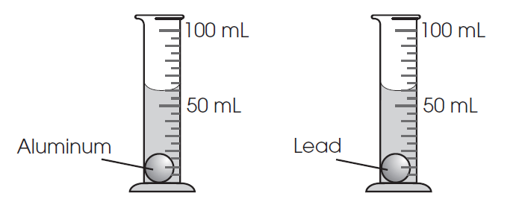

2. Which tool did the student use to measure the mass of each metal ball? (Don’t let the picture trick you.)
A. ruler
B. timer
C. balance
D. graduated cylinder
Name: ___________________Period:_____

3. The student includes the sentence below in the data section of this investigation.

The lead ball has a measured mass of 113 grams.

Which kind of scientific statement is this sentence?
A. inference
B. prediction
C. variable
D. observation

4. In repeating the investigation, the student accidentally drops and steps on the lead ball. This
action changes its shape from a sphere to an egg-shaped solid. The lead ball is placed back into the
graduated cylinder. Below, predict what effect, if any, this change has on the amount of water
displaced by the lead ball. Explain your prediction.
(Think: Has the amount of matter in the ball changed or is it still the same? Did you take away or add any matter to the ball when squished?) (2 points)

5. Identify this lab tool.

- Beaker
- Test Tube
- Erlenmeyer Flask
- Graduated Cylinder
