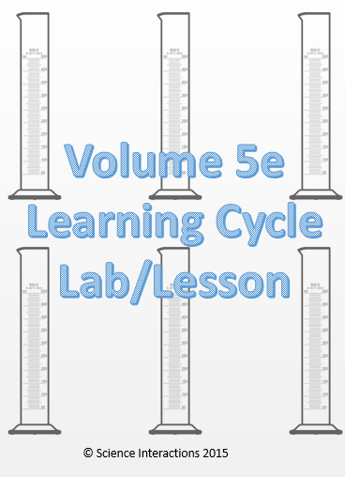
Name: _______________________________ Period: _____
Volume
Engage:
How much water is in the graduated cylinder on your desk? How do you know?
Explore:
Fill-out the chart below as you follow these steps:
- Be sure that your graduated cylinder measures exactly 40 mL. Remember to read the measurement from the bottom on the meniscus (curve) at eye level.
- Place the stone on your desk into the graduated cylinder. Record the water level measurement.
- Subtract the starting water level from the new water level. Water Level with Rock – Starting Water Level = ??
Object | A. Starting Level | B. After Object | Subtract (B-A) | Difference
Rock | 40mL | mL | mL | mL
Marble | 40mL
Bolt | 40mL
- Now, repeat steps 1-3 with the marble and the bolt.
- Concept Development: What does this difference in the starting level of the water and the water level after adding the object tell you?

- Is it necessary to always start at 40 mL. Explain why or why not?

STOP HERE: Teacher Notes
(Measuring Volume with a Graduated Cylinder Notes Page)
Application:
Now, let’s find the volume of a few objects that are too large for the graduated cylinder.
- Fill the gray overflow can as full as you can without it overflowing out the spout.
- Place a small beaker beside the can under the spout.
- Place one of your larger objects in the overflow can; the beaker will catch any water that spills from the spout.
- Dump the water in the beaker into your graduated cylinder. Record this amount of water in the chart on the back.
- If any of your objects float, push them under the water level with a straightened paper clip.
- Convert your over flow to cm³. A milliliter (mL) is the same as a cubic centimeter (cm³).
Object | Volume of Overflow (mL) | Volume of Object (cm³)
Matchbox Car
Egg
Ball
Your Choice: _________________
- What does this amount of “overflow” water represent?

- What is volume? Define this in a complete sentence.

- Find the volume of liquid in each graduated cylinder below. Label your answers. 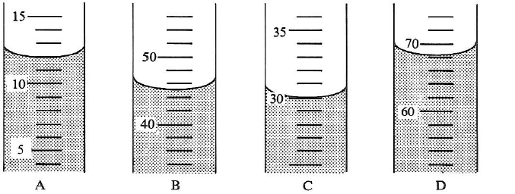

- _____________ B. _____________ C. _____________ D. _____________

