Science Boxes 7-1 Due Date: _________

1. Students study how water changes from liquid to gas. These are the steps in the class investigation.
Materials: electric heating coil, beaker, and thermometer
Procedure:
1. Pour one liter of water into the beaker.
2. Place the thermometer in the water.
3. Record the temperature of the water.
4. Place the beaker on the heating coil.
5. Turn on the heating coil.
6. Record the temperature of the water every minute for 10 minutes.
Below, identify one possible safety hazard in this investigation. Also describe one way to make sure this is a safe investigation. (2 points)

- A student will measure and record the growth
of two plants every other day for 10 days.
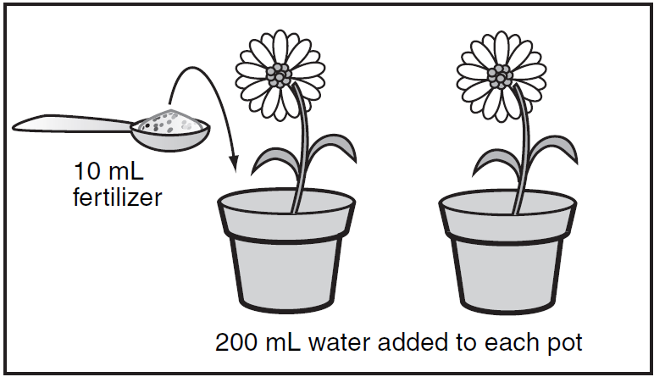
According to the diagram, which question is being tested?
- Do flowering plants grow better when watered with salt water?
- How much fertilizer do flowering plants need?
- Does fertilizer added to the soil lead to taller flowering plants?
- How tall do flowering plants grow?

Name: ___________________Period:_____

- Which of the following questions is testable in a scientific investigation?
A. Are dogs better pets than cats?
B. Are dogs happy when they are walked?
C. Are cats more active at night than during the day?
D. Are cats easier to take care of than dogs?

4. The teacher asks the class to use cups to collect soil samples from the yard. The students collect the soil from two locations near the sidewalk.
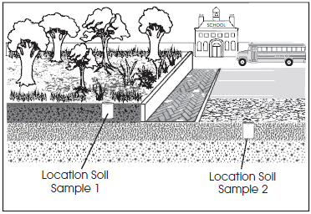
The students record their observations of the soil samples in the table below.
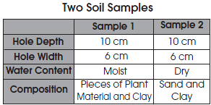

What explains why the composition of the soil samples is so different?
A. The students took samples at different times.
B. The students collected samples from different layers.
C. The students used different tools to observe the samples.
D. The students used different-sized cups to collect the samples

