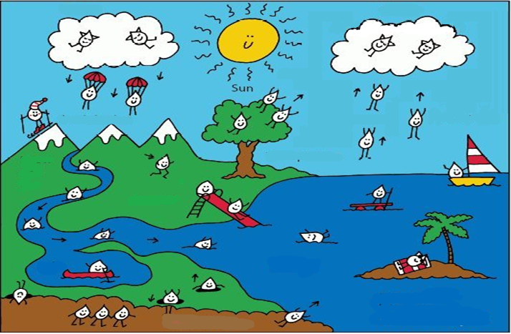
Cut out the words below and label the water cycle diagram. Paste the words down when complete.
Hydrological Cycle
Clouds | Precipitation | Condensation | Transpiration
Evaporation | Snow & Ice | Runoff | River
Lake | Surface Water | Salt Water | Collection

*Water cycle diagram found online. Modified for my needs.

